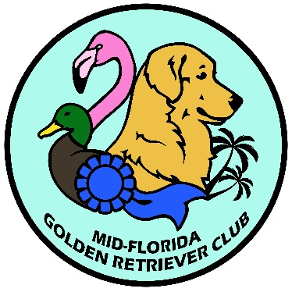
General Meeting Minutes
February 13, 2024

Time: 7:00 p.m.
Location: Zoom

WELCOME: Robin Burket called the meeting to order at 7:03 p.m. and listed some of the events we’ve had so far this year.

REPORTS:
Secretary – Cindy Patz brought the December and January minutes up for discussion and approval. Robin Burket motioned that the minutes should be approved as posted and the motion was seconded by Kristin Sipus. The motion passed unopposed.

Treasurer – Robin Bowen reported that all our bills have been paid and she is still finalizing the financials from the February Hunt Test, but it seems like we will be making money. The 50/50 raffle at the Hunt Test brought in $191.00 which will help cover the increased duck expenses.

COMMITTEE REPORTS:
Hunt test – Kristin Sipus reported that the Hunt Test was a great success and had good feedback from the competitors, judges and volunteers. She expressed her appreciation for everyone that volunteered for the event.

UNFINISHED BUSINESS:
Robin Burket reported that the Fun Match premium with entry form has been emailed and uploaded to the website. Ann Rowe said we need volunteers for set up on Friday before the event starting at 12:00 pm and on the day of the event. Lunch will be from Sonny’s and please bring a raffle item.

Robin Burket also reminded members that we are always looking for guest speaker ideas, so please share with us if they have any.

NEW BUSINESS:
Robin Burket discussed the upcoming events and expressed the need for volunteers.
- Barn Hunt February 24th- Michele Throm reported that there are still 2 spots available in the morning session.
- Fun Match March 16^{th –} Robin Bowen mentioned that the new title rosettes can be picked up at the Fun Match
- Dock Diving – Courtney Roxby reported that the event will be held at Central Florida K-9 in Eustis, Florida on Sunday, April 14th
- CCI Dog Fest Fundraiser April 20th- Robin Burket reported that fundraising is now open, so please sign up and donate with our MFGRC team – goal is $1500.00. You can go to FB page to donate but will send out in email for those not on FB.
- Heart/Eye Clinic May 4th – at MADTA in Ocala; Camille reported the same doctor we used last year will be doing the heart clinic and a flyer will be sent out in the next week or so with the forms.
- CCA/Breeder Education Seminar May 5th – also held at MADTA and a separate flyer will be sent out for this event.
- Obedience Trial August 9th-11th – no new information was reported.
- Summer Specialty - Michele Panetta reported that the show will be Saturday, July 6th at WEC and she listed the judges. Since this is the club’s 40th anniversary, she is looking for ruby colored and themed prizes. She also reported that we will have a cupcake cake, but WEC needs to approve the cake.
- Raffle will be held at the Specialty – Julie Wangelin is happily accepting donations for the raffle and reported that we already have a special raffle item: a week in Puerto Rico!
- Survey – Robin Burket discussed that the board is putting together a new survey to see where the membership’s interests are focused and see where we can expand on what we offer as a club.

Brags:
Many brags were reported from this past weekend’s Hunt Tests (both AKC and UKC) and recent conformation shows.

Next Board Meeting is March 5th at 6 pm on Zoom
Next General Meeting is March 16th at the Fun Match in Sorrento, FL

Motion to adjourn – Ann Rowe motioned to adjourn and was seconded by Camille Nasca. The meeting was adjourned at 7:35 p.m.

