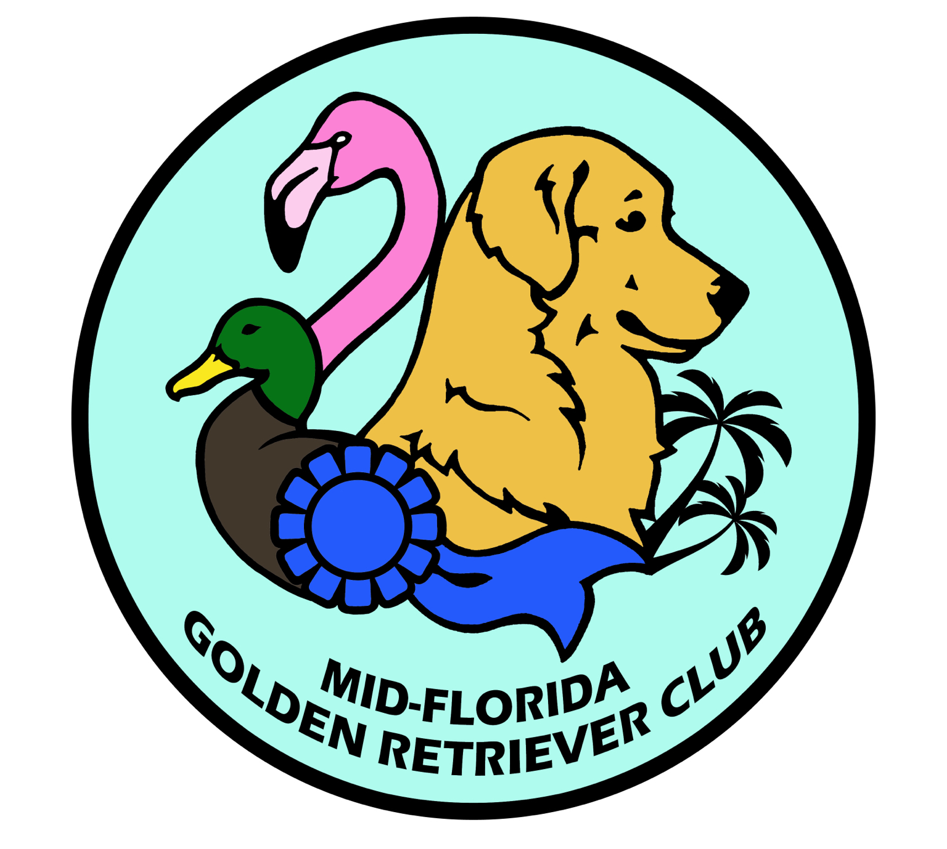
Heart and eye clinic

July 20, 2019
New air-conditioned MADTA Building
6600 NW 3rd Place
Ocala, FL 34482

Dr. Darcy Brittain Adin OFA heart exam

Auscultation _____ $55.00
Echocardiogram _____$225.00
Registration after 7/10/19___ +$5.00
***Golden Retriever/ Min. Schnauzer/ Doberman Pinchers, interested in participating in DCM study, having echo may qualify for free Taurine testing.

Dr. Ralph Hamor

OFA Eye exam______ $35.00
Preliminary exam required for:
Basenji, Mastiff, Dalmatian, Australian Shepherds & Pembroke Welsh Corgi
___ +$5.00
Registration after 7/10/19___ +$5.00

Total payment ____________ make checks payable to MFGRC
Pre registration required - must be received by: July 10, 2019
space is limited please sign up early-

Mail to: Kristin Sipus 4751 SE 216th Ave. Morriston, FL 32668
352-229-1575 richwoodgoldens@gmail.com
One dog per form- all breeds welcome
Dog name:_________________________________________
Breed_____________________________________________
Owner_____________________________________________
email______________________________________________
phone#___________________cell#_____________________

You will be contacted to schedule time

Is this dog entered in CCA___________

